Psychopharmacology Reference Notebook

Tonya L. Buchanan
Department of Nursing, King University
NURS 5075: Advanced Psychopharmacology
Dr. Nicole Walters
December 6, 2021

Neurotransmitters Chart
 | Function  (Excitatory or Inhibitory) | Locations | Receptors | Effects of Deficient | Effects of Surplus | Agonist Drug | Antagonist Drug
Acetylcholine | Stimulates muscle control; use in memory, attention, learning  Excitatory and Inhibitory | (Neuromuscular) Junction (Preganglionic autonomic synapse) (Postganglionic parasympathetic synapses) (Basal forebrain projections to hippocampus and amygdala) | Nicotinic receptors | Lack of muscle movement and control  (Alzheimer’s) | Severe muscle spasms,  emotional lability, irritability, anger, aggressiveness, negative rumination, impatience,  and impulsiveness | Nicotine  Black widow spider venom  Muscarine | Curare  Botox  Atropine  Scopolamine
Dopamine | Voluntary movement, attention, learning  Excitatory and Inhibitory | (Substantia nigra and basal ganglia) (Ventral tegmentum projections to hippocampus, amygdala, and nucleus accumbens) (Ventral tegmentum projections to frontal lobe of the cortex) | D1  D2  D3  D4  D5 | Anxiety disorders, memory problems, ADHD, Parkinson’s | Schizophrenia, drug addiction | L-dopa, cocaine | Antipsychotic drugs  Chlorpromazine
Endorphins | Pain perception and positive emotions  Inhibitory | Pituitary glands | Opiate receptors in the brain | Pain is experienced | Body may not give adequate warning of pain, artificial highs | Opiates | Naloxone
GABA | Offsets excitatory messages and regulates sleep-wake cycle  Inhibitory | Widely distributed in the central nervous system | ionotropic (GABAA) and metabotropic  (GABAB) | Anxiety, seizures, tremors, insomnia | Sleep and eating disorders | Valium, Xanax | Tiagabine
Glutamate | Used in memory, learning, movement, help messages cross synapse  Excitatory | Widely distributed in the central nervous system | NMDA receptors,  AMPA receptors, and kainite receptors | Insomnia, problems concentrating, mental exhaustion and depleted energy | Anxiety, depression, restlessness, inability to concentrate, headaches, insomnia, fatigue, and increased sensitivity to pain. | MSG  NMDA  AMPA | Lamotrigine  Ketamine
Glycine | Processes motor sensory function, permits movement, vision  Inhibitory | Spinal cord, brainstem | NMDA subtype glutamate receptor | Muscular convulsions, asphyxia, death | Fatal hyperexcitability in brain | Amino acids | Strychnine
Norepinephrine | Used for arousal in fight or flight, mood, learning, memory retrieval  Excitatory | (Pons) (Medulla) (Hypothalamus) (Postganglionic sympathetic synapses) | Alpha- and beta-adrenergic receptors | Mental disorders such as depression.  hyperactivity, compulsive behavior | High blood pressure. anxiety. excessive sweating. heart palpitations. headaches. | Caffeine  Amphetamines  Moclobemide | Lithium
Serotonin | Moods, emotional states, hunger, sleep, and wakefulness  Inhibitory | Projections originate in the pons, particularly to the raphe nucleus and project widely in the brain and spinal cord | 5-HT receptors | Depression, mood disorders | Autism, mania | SSRIs  Sumatriptan  Zolmitriptan | Zofran  Ergotamine

Fill in boxes to indicate function of each component. Study the differences between the CNS and PNS as well as the SNS and ANS. These differences are important to understand as a PMHNP.

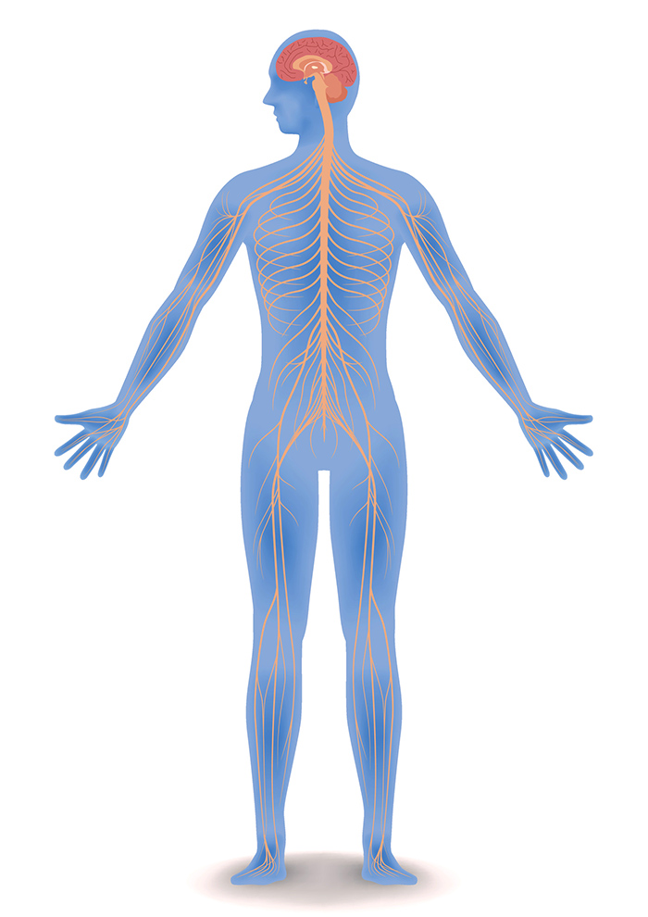
Central Nervous System
Nervous System
Peripheral Nervous System
Spinal Cord
Connects brain to body and controls movements
Autonomic Nervous System
Responsible for involuntary movement (heartbeat, pupil dilation)
Somatic Nervous System
Responsible for voluntary movements (muscle movement)

Brain
Controls thought, memory, emotion, touch, motor skills, vision, breathing, temperature, hunger

Sympathetic Division
Responsible for fight or flight response

Parasympathetic Division
Responsible for rest and relax actions (digestion)
Sensory (afferent) neurons
Carries nerve impulses from sensory stimuli toward the CNS and brain.
Motor (efferent) neurons
Transmits impulses from the CNS out to the peripheral organs to cause an effect or action

HPA Axis and Hormones Involved

Hypothalamus-its function is to send messages from the brain to the adrenals, the pituitary and other organs (Corticotrophin Releasing Hormones).

Pituitary Gland-it produces vital hormones like Growth Hormone (GH), Luteinizing Hormone (LH), and Anti-diuretic (ADH). (Adrenocorticotrophic Hormone)

Adrenal Gland-produces a wide variety of hormones that help control heart rate and other adrenal gland function that are involved in stress reactions. (Catecholamines-epinephrine, norepinephrine, aldosterone) (Glucocorticoids-cortisol)

Antipsychotics
First Generation |  |  |  |  |  |  |  | Side Effects (L=Low, M=Moderate, H=High)
Generic Name | Trade Name | Route(s) of Administration | LAI option | Starting Dose | Half Life | Indications (s/sx & diagnosis) | MOA (neurotransmitter effects) | EPS | Hyperlipidemia | T2DM | Weight Gain | Cognitive Issue | Other SE | Costs
CHLORPROMAZINE | THORAZINE | Oral, IM, IV, suppository | NO | 30-75mg a divided in 6-12hrs | 8-33 HRS | Schizophrenia, psychotic disorders | Blocks D2 receptors | M | L | L | M | H | NMS, TD, priapism, sedation | $100-150 for tablets
FLUPHENAZINE | PROLIXIN | Oral, IM, sub q, elixir | YES | 0.5-10mg oral  1.25-10mg IM q6-8 hrs. | 15 hrs. oral  7-10 days IM | Bipolar, psychotic disorders | Dopamine 2 antagonist | M | L | L | M | L | Seizures, agranulocytosis,  Renal failure | $50-100 for tabs
HALOPERIDOL | HALDOL | Tablets, IM, concentrate | YES | 1-40 mg oral  2-5 mg | 12-38 hrs. oral  LAI 3wks | Bipolar, delirium, schizophrenia, psychotic disorders | Dopamine receptor agonist | M | L | L | M | L | NMS, seizures, jaundice, agranulocytosis | $10-20
LOXAPINE | LOXITANE | Capsule, liquid, IM, inhalant | NO | 20mg in two doses for 1st wk | 4 hrs. oral  12 hrs. IM | Schizophrenia, bipolar, psychotic disorders | Blocks dopamine 2 receptor | M | L | L | L | M | Seizures, agranulocytosis,  Renal failure | $13-17
MOLINDONE | MOBAN | Tablet, liquid | NO | 50-75mg daily | 1.5 hrs. | Schizophrenia,  bipolar | Blocks dopamine 2 receptor | M | L | L | L | M | Leukopenia, seizures, rhabdomyolysis | $200-300
PERPEHNAZINE | TRILAFON | Tablet, injection | NO | 4-8 mg TID | 9.5 hrs. | Schizophrenia,  Nausea and vomiting, bipolar | Blocks dopamine 2 receptor | M | L | L | M | M | Seizures, agranulocytosis, jaundice | $16-25
THIORIDAZINE | MELLARIL | Tablet, liquid, suspension | NO | 50-100 TID | 21-24 hrs. | schizophrenia | Blocks dopamine 2 receptor | M | L | L | M | M | NMS, renal failure, seizures | $23-40
THIOTHIXENE | NAVANE | Capsule | NO | 15-30 mg a day | 3.4 hrs. | Schizophrenia, bipolar, psychotic disorders | Blocks dopamine 2 receptor | M | L | L | L | L | NMS, seizures, blood dyscrasias, hepatic toxicity | $36-90
TRIFLUOPERAZINE | STELAZINE | Tablet | NO | 15-20 mg a day | 12.5 hrs. | Schizophrenia, bipolar, psychosis | Blocks dopamine 2 receptor | M | L | L | L | M | Agranulocytosis, jaundice, renal failure, NMS | $40-100

Notes:

Second Generation |  |  |  |  |  |  |  |  | l
ARIPIPRAZOLE | ABILIFY | PO/IM | YES | 10-15 mg QD | 75 hrs | Schizophrenia, bipolar disorder, major depressive disorder, Tourette disorder, and irritability associated with autistic disorder in children | Partial antagonist activity at dopamine and serotonin receptors and antagonist activity at serotonin receptors. | M | L | M | M | L | Neuroleptic malignant syndrome, tardive dyskinesia, headache, insomnia, vomiting. | $12.97
BREXPIPRAZOLE | REXULTI | PO | NO | Start 0.5-1mg PO qd, may increase every week. Max 3 mg/day | 91 hrs | Major depressive disorder, schizophrenia | partially agonizes dopamine D2 and serotonin 5-HT1A receptors, antagonizes serotonin 5-HT2A receptors | H | M | M | M | M | feeling restless or being unable to sit still. | $1,117.38
CARIPRIZANE | VRAYLAR | PO | NO | Start 1.5 mg PO qd, may increase to 3 mg PO qd, max 6 mg/day. | 2-4 days (parent drug), 1-3wk (active metabolite) | Schizophrenia, bipolar disorder (manic/mixed), bipolar disorder (depressive) | partially agonizes dopamine D2 and serotonin 5-HT1A receptors, antagonizes serotonin 5-HT2A receptors | H | L | M | M | H | involuntary muscle movements; upset stomach, vomiting; drowsiness; or feeling restless. | $1,239.65
CLOZAPINE | CLOZARIL | PO | NO | Start 12.5mg PO qd-bid, increase by 25-50 mg/day to target 300-450 mg/day in divided doses. | 4-66 hrs. | Schizophrenia, tx-resistant, and suicide prevention, schizophrenia associated. | antagonizes dopamine D2 receptors, serotonin 5-HT2 receptors, alpha adrenergic receptors, cholinergic muscarinic receptors, others | M | L | M | M | M | Drowsiness, tachycardia, dizziness, constipation, hypotension, headache, diaphoresis, etc. | $33.74
LURASIDONE | LATUDA | PO | NO | Schizophrenia- Start: 40 mg PO qd; Max: 160 mg/day  Bi-polar- Start: 20 mg PO qd; Max: 120 mg/day | 18 hrs | Schizophrenia, Bi-polar disorder | antagonizes dopamine D2 receptors, serotonin 5-HT2A receptors, others | M | L | M | M | M | Somnolence, akathisia, nausea, vomiting, diarrhea, dyspepsia, agitation, anxiety | $1,299.90
OLANZAPINE | ZYPREXA | PO | NO | Start: 5-10 mg PO qd, | 21-54 hrs. | Schizophrenia, bipolar I disorder, agitation, acute depression with bipolar I, nausea/vomiting prevention- chemo related | antagonizes dopamine, serotonin 5-HT2, and other receptors (thienobenzodiazepine) | M | M | M | H | M | Xerostomia, dyslipidemia, headaches, insomnia, dizziness, back pain, speech disturbances | $4.50
PALPERIDONE | INVEGA | PO, IM | YES | 6mg PO qam | 23 hrs | Schizophrenia, schizoaffective disorder | antagonizes dopamine D2 receptors, serotonin 5-HT2A receptors, others | H | L | M | M | M | Parkinsonism, tachycardia, headache, somnolence, anxiety, nausea, dizziness | $83.09
QUETIAPINE | SEROQUEL | PO | NO | Start: 25 mg PO bid, then incr. by 50-150 mg/day up to 300-400 mg/day PO divided | 6-7h, 7-12h (ER) | Schizophrenia, bipolar I disorder, manic, generalized anxiety disorder, tx resistant | antagonizes dopamine D2 receptors, serotonin 5-HT2 receptors, others | M | L | M | M | M | Somnolence, xerostomia, orthostatic hypotension, tachycardia, constipation | $3.00
RISPERIDONE | RISPERDAL | PO, IM, SC | YES | Start 1-2 mg/day PO | 20h (PO), 3-6 days (IM), 9-11 days (SC) | Schizophrenia, bipolar disorder, Tourette syndrome | antagonizes dopamine D2 receptors, serotonin 5-HT2 receptors, others | H | L | M | H | M | Severe hypotension, syncope, tardive dyskinesia, neuroleptic malignant syndrome | $1.50
ZIPRASIDONE | GEODON | PO, IM | YES | Start 20mg PO bid, nax 160mg  10mg IM q12h prn | 7 hrs | Schizophrenia, bipolar disorder | antagonizes dopamine D2 receptors, serotonin 5-HT2A receptors, others | H | M | M | M | M | Headaches, dizziness, nausea, visual disturbances, rash, edema | $12.83

Antidepressants, Anxiolytics & Mood Stabilizers
Antidepressants |  |  |  |  |  |  |  | Side Effects (L=Low, M=Moderate, H=High)
Generic Name | Trade Name | Route(s) of Administration | LAI option | Starting Dose | Half Life | Indications (s/sx & diagnosis) | MOA (neurotransmitter effects) | EPS | Hyperlipidemia | T2DM | Weight Gain | Cognitive Issue | Other SE | Costs
SSRIs
CITALOPRAM | CELEXA | Tablet, solution | NO | 20-40 mg a day | 23-45 hrs. | Depression, PMS, OCD, panic disorder, GAD, PTSD, social phobia | Blocks serotonin reuptake pump | L | L | L | L | L | Seizures, mania, suicidal ideation, SIADH | $2-20
ESCITALOPRAM | LEXAPRO | Tablet, oral solution | NO | 10mg a day | 27-32 hrs. | MDD, GAD, panic disorder, OCD, PTSD, PMDD, social phobia | Blocks serotonin reuptake pump | L | L | L | L | L | Sexual dysfunction, sweating, bruising | $3-35
FLUOXETINE | PROZAC | Capsule, tablet, liquid, weekly capsule | NO | 20-80mg a day | 2 week | MDD, OCD, PMDD, bulimia, panic disorder, PTSD | Blocks serotonin reuptake pump | L | L | L | L | L | Sexual dysfunction, GI upset, insomnia, SIADH | $3-30
FLUVOXAMINE | LUVOX | Tablet, control release capsule | NO | 100-300 mg a day | 9-28 hrs. | OCD, GAD, PTSD, depression, panic disorder | Blocks serotonin reuptake pump | L | L | L | L | M | Sexual dysfunction, GI upset, insomnia, sweating | $23-50
SERTRALINE | ZOLOFT | Tablet, oral solution | NO | 50-200 mg a day | 22-36 hrs. | MDD, GAD, OCD, PTSD, PMDD, social phobia | Blocks serotonin reuptake pump | L | L | L | L | L | Sexual dysfunction, GI upset, insomnia, sweating | $3-20
PAROXETINE | PAXIL | Tablet, control release capsule, liquid | NO | 20-50 mg a day | 24 hrs. | MDD, OCD, PTSD, GAD, PMDD, social phobia | Blocks serotonin reuptake pump | L | L | L | M | M | Sexual dysfunction, GI upset, insomnia, sweating | $3-30
VILAZODONE | VIIBRYD | tablet | NO | 20-40 mg a day | 25 hrs. | MDD, OCD, anxiety | Blocks serotonin reuptake pump | L | L | L | L | L | Sexual dysfunction, NVD insomnia, sweating | $300
VORTIOXETINE | TRINTELLIX | tablet | NO | 5-20 mg a day | 66 hrs. | MDD, GAD, geriatric depression | Blocks serotonin reuptake pump | L | L | L | L | L | Sexual dysfunction, nausea, vomiting | $400
SNRIs
DESVENLAFAXINE | PRISTIQ | Extend release tablet | NO | 50 mg a day | 9-13 hrs. | MDD, GAD, PTSD, PMDD, panic disorder, social phobia | Blocks serotonin and NE reuptake pump | L | L | L | L | L | Insomnia, sedation, GI upset, sexual dysfunction, sweating | $20-80
DULOXETINE | CYMBALTA | Capsule | NO | 40-60 mg a day | 12 hrs. | MDD, DPNP, fibromyalgia, GAD, neuropathy, muscle pain, | Blocks serotonin and NE reuptake pump | L | L | L | L | M | GI upset, insomnia, increased BP | $6-50
LEVOMILNACIPRAN | FETZIMA | Extend release capsule | NO | 40-120 mg a day | 12 hrs. | MDD, neuropathic pain, fibromyalgia | Blocks serotonin and NE reuptake pump | L | L | L | L | M | Insomnia, urinary retention, tachycardia, ED | $400
VENLAXAFINE | EFFEXOR | Capsule, tablet | NO | 75-150 mg a day | 3-7 hrs. | Depression, GAD, PTSD, PMDD, panic disorder, social disorder | Blocks serotonin and NE reuptake pump | L | L | L | L | M | HA, insomnia, GI upset, sexual dysfunction | $6-30
TCAs
AMITRIPTYLINE | ELAVIL | TAB | NO | 50-150 MG A DAY | 10-28 HRS. | Neuropathic pain, fibromyalgia, HA, low back pain, anxiety, insomnia | Blocks serotonin and NE reuptake pump | M | M | M | M | M | Dry mouth, blurred vision, cardiac arrhythmias, fatigue | $4-20
CLOMIPRAMINE | ANAFRANIL | Capsule | NO | 100-200 mg a day | 17-28 hrs. | OCD, depression, treatment resistant depression, anxiety, insomnia, neuropathy | Blocks serotonin and NE reuptake pump | M | M | M | M | M | Sexual dysfunction, cardiac arrythmias, sedation, blurred vision | $24-80
DESIPRAMINE | NORPRAMIN | Tablet | NO | 100-200 mg a day | 24 hrs. | Anxiety, insomnia, treatment resistant depression, neuropathy | Blocks NE reuptake pump, increases dopamine | M | M | M | M | M | Dry mouth, constipation, weight gain, cardiac arrythmias | $23-60
DOXEPIN | SINEQUAN | Capsule, solution, topical, tablet | NO | 75-150 mg a day | 8-24 hrs. | Depression, psychotic depression, manic-depression, dermatitis, pruritis, anxiety | Blocks serotonin and NE reuptake pump | M | M | M | M | M | Dry mouth, constipation, weight gain, cardiac arrythmias | $18-30
IMIPRAMINE | TOFRANIL | Capsule, tablet | NO | 50-150 mg a day | 19 hrs. | Enuresis, anxiety, insomnia, neuropathy, treatment resistant depression | Blocks serotonin and NE reuptake pump | M | M | M | M | M | Sexual dysfunction, cardiac arrythmias, sedation, blurred vision | $4-15
NORTRIPTYLINE | PAMELOR | Liquid, capsule | NO | 75-150 mg a day | 36 hrs. | Anxiety, insomnia, neuropathy, treatment resistant depression | Blocks serotonin and NE reuptake pump | M | M | M | M | M | Sexual dysfunction, cardiac arrythmias, sedation, blurred vision | $6-20
MAOIs
ISOCARBOXAZID | MARPLAN | tablet | NO | 40-60 mg a day | 1.5-4 hrs. | Treatment resistant depression, panic disorder, social anxiety | Irreversibly blocks MAO from breaking down NE, serotonin, and dopamine | L | M | M | M | M | Insomnia, hypotension, dizziness, HA, sedation, sexual dysfunction | $700
PHENELZINE | NARDIL | Tablet | NO | 45-75 mg a day | 11.6 hrs. | Atypical depression, treatment resistant depression, anxiety panic disorder | Irreversibly blocks MAO from breaking down NE, serotonin, and dopamine | L | M | M | M | M | Sexual dysfunction, sedation, constipation, dry mouth, weight gain, low BP | $28-57
SELEGILINE | ELDEPRYL | Transdermal patch, capsule, tablet sublingual | NO | 30-60 mg a day | 18-25 hrs. | MDD, Parkinson’s, treatment resistant depression, social anxiety, Alzheimer’s | Irreversibly blocks MAO from breaking down NE, serotonin, and dopamine | L | L | L | M | M | Low BP, weight gain, hallucinations, nausea, dizziness, abdominal pain, HA | $60-100
TRANYLCYPROMINE | PARNATE | Tablet | NO | 30-50 mg a day | 2.5 hrs. | MDD, treatment resistant depression, panic disorder, social anxiety | Irreversibly blocks MAO from breaking down NE, serotonin, and dopamine | L | M | M | M | M | Agitation, anxiety, insomnia, weakness, sedation, weight gain, sexual dysfunction | $100-200
Atypical
BUPROPRION | WELLBUTRIN | Tablet | NO | 75-150 mg a day | 10-14 hrs. | MDD, SAD, bipolar, ADHD, sexual dysfunction, nicotine addiction | Blocks NE reuptake pump, can increase dopamine | L | L | L | L | L | Anorexia, dry mouth, nausea, insomnia, sweating, HTN | $8-40
KETAMINE | KETALAR | Oral, IV infusion, IM | NO | 10-50 mg oral  1-10 units IV  50-100 mg IM | 45 minutes | General anesthesia, neuropathic pain, pain, sedation, treatment resistant depression | Non-competitive open channel inhibitor of NMDA, analgesic | L | L | L | L | H | Syncope, Hypo and hypertension, CNS depression, urinary tract toxicity | Price will vary on facility and insurance
MIRTAZAPINE | REMERON | Tablet, solutab | NO | 10-45 mg at bedtime | 20-40 hrs. | MDD, panic disorder, GAD, PTSD | Boosts serotonin and NE, blocks alpha 2 adrenergic presynaptic receptor | L | M | M | M | M | Dry mouth constipation, dizziness, weight gain, sedation, hypotension | $4-30
TRAZODONE | DESYREL | Tablet | NO | 150-600 mg a day | 3-6 hrs. | Insomnia, anxiety, depression | Blocks serotonin 2A receptors and serotonin reuptake pump | L | L | L | L | M | Nausea, vomiting, edema, dry mouth, dizziness, sedation, rash | $3-30
Anxiolytics
Benzodiazepines
ALPRAZOLAM | XANAX | Tablet, solution, ER tab | NO | 1-4 mg a day | 11.2 hrs. | GAD, Panic disorder, insomnia, acute mania, acute psychosis, catatonia | Binds to benzodiazepine receptor at the GABA ligand-gated chloride channel complex | L | L | L | L | M | Sedation, fatigue, depression, confusion, hallucinations, hypotension | $2-4
CLONAZEPAM | KLONOPIN | Tablet, wafer | NO | 0.5-2 mg a day | 30-40 hrs. | Panic disorder, akinetic seizures, myoclonic seizures, atonic seizures, anxiety, acute mania, acute psychosis, insomnia | Binds to benzodiazepine receptor at the GABA ligand-gated chloride channel complex | L | L | L | L | H | Respiratory depression, sedation, fatigue, low BP, confusion, dizziness, ataxia | -$2-15
DIAZEPAM | VALIUM | IV, tablet, nasal spray, IM, suppository, rectal gel, solution | NO | 4-40 mg a day oral  5 mg/min IV adults | 20-50 hrs. | Anxiety, acute tremor or agitation, DTs, muscle spasm, athetosis, stiff man syndrome, insomnia, catatonia | Binds to benzodiazepine receptor at the GABA ligand-gated chloride channel complex | L | L | L | L | H | Sedation fatigue, depression, forgetfulness, dizziness, ataxia, confusion | $3-10
LORAZEPAM | ATIVAN | Tablet, liquid, IM | NO | 2-6 mg a day oral  4 mg IM | 10-20 hrs. | Anxiety, seizures, insomnia, muscle spasm, DTs, HA, panic disorder, acute mania or psychosis, catatonia | Binds to benzodiazepine receptor at the GABA ligand-gated chloride channel complex | L | L | L | L | H | Respiratory depression, sedation fatigue, depression, confusion, ataxia, weakness | $3-11
OXAZEPAM | SERAX | Capsule, tablet | NO | 30-60 mg a day in divided doses | 3-21 hrs. | Anxiety, alcohol withdrawal, catatonia | Binds to benzodiazepine receptor at the GABA ligand-gated chloride channel complex | L | L | L | L | H | Respiratory depression, liver dysfunction, renal dysfunction, blood dyscrasias | $25-60
TEMAZEPAM | RESTORIL | Capsule | NO | 15 mg a day at bedtime | 8-15 hours | Insomnia, catatonia | Binds to benzodiazepine receptor at the GABA ligand-gated chloride channel complex | L | L | L | L | H | Respiratory depression, liver dysfunction, renal dysfunction, blood dyscrasias | $4-12
Barbiturates
PENTOBARBITAL | NEMBUTAL | IV, IM | NO | 150-200mg IM  70-100 mg IV | 15-50 hrs. | Sedative, short-term insomnia | Non-selective CNS depressant, sedative hypnotics, anticonvulsant, | L | L | L | L | H | Confusion, memory difficulty, irritability, aggression, nightmares, nervousness | Administered by professional providers
BUTALBITAL COMBINATIONS | FIORICET  FIORINAL | capsules | NO | 2 capsules every 4 hours as needed for migraine not to exceed 6 in 24 hrs. | 36 hrs | Migraines | Stimulates brain’s production of GABA | L | L | L | L | L | Nausea, vomiting, abdominal pain, SOB, dizziness, drowsiness, sleepiness, | $8-20

Mood Stabilizers
CARBAMAZEPINE | TEGRETOL | PO | NO | Start 200mg PO bid, increase by 200mg/ day every week. Max 1600 mng/day | 25-65 hrs. | Seizure disorder, trigeminal neuralgia, bipolar disorder | reduces post-tetanic potentiation, decreasing seizure spread; exact mechanism of action in trigeminal neuralgia or bipolar disorder unknown | L | L | M | L | M | Dizziness, drowsiness, unsteadiness, nausea, vomiting, ataxia, constipation, pruritus | $16.65
GABAPENTIN | NEURONTIN | PO | NO | Start 300mg PO tid, | 5-7 hrs | Partial seizures, post-herpetic neuralgia, neuropathic pain, fibromyalgia, alcohol dependence | blocks voltage-dependent calcium channels, modulating excitatory neurotransmitter release | L | L | L | M | M | Dizziness, somnolence, ataxia, fatigue, fever, peripheral edema, nystagmus | $5.03
LAMOTRIGINE | LAMICTAL | PO | NO | Start 25mg a day and increase weekly to achieve 200mg dose. Max 200mg per day. | 25 hrs | Bipolar disorder, seizures, migraine headaches. | inhibits voltage-dependent sodium channels, decreasing presynaptic glutamate and aspartate release | M | L | M | L | M | Vertigo, headache, diplopia, ataxia, nausea, vomiting, blurred vision | $3.00
LEVATIRACETAM | KEPPRA | PO, IM, IV | YES | Start 500 mg PO/IV q12h | 6-8 hrs | Partial seizures, juvenile epilepsy, tonic-clonic seizures | selectively prevents hypersynchronization of epileptiform burst firing | M | L | M | L | M | Headache, BP increase, somnolence, asthenia, URI sx | $6.00
LITHIUM | ESKALITH  LITHOBID | PO | NO | Start 300 mg PO tid | 18-36 hrs | Bipolar disorder, schizoaffective disorder | alters neuronal sodium transport | L | L | M | M | M | Tremor, polyuria, polydipsia, diarrhea, vomiting, drowsiness | $46.88
OLANZIPINE PLUS FLUOXETINE | SYMBYAX | PO | NO | Start 6mg/25mg PO qpm | 21-54 hrs | Bipolar disorder, major depressive disorder | antagonizes dopamine, serotonin 5-HT2, and other receptors (thienobenzodiazepine); fluoxetine selectively inhibits serotonin reuptake | M | L | M | H | M | Somnolence, increase in appetite, xerostomia, edema, fatigue, asthenia | $71.39
OXCARBAZEPINE | TRILEPTAL | PO | NO | Start 300 mg PO bid | 2 hrs | Partial seizures, bipolar disorder | blocks voltage-sensitive Na channels, stabilizes neural membranes, inhibits repetitive firing, and decr. synaptic impulse propagation | L | L | M | L | M | Dizziness, headache, nausea, vomiting, diplopia, balance disorder, fatigue | $9.00

Notes:

Psychiatric Emergencies and Adverse Reactions

Complete the chart below with the following information:
- Onset and Causes
- Additional Notes
- S/Sx: Signs and Symptoms
- Tx: Treatment

Example:
Emergency | Neuroleptic Malignant Syndrome (NMS)
Onset/Causes | - within hours or days after exposure to a causative drug, with most exhibiting symptoms within 2 weeks and nearly all within 30 days  - Primary trigger of NMS is dopamine receptor blockade, and the standard causative agent is an antipsychotic. Potent typical neuroleptics such as haloperidol, fluphenazine, chlorpromazine, trifluoperazine, and prochlorperazine have been most frequently associated with NMS and thought to confer the greatest risk.  - Idiosyncratic-time limited reaction
Additional Notes | - More common in men than women
S/Sx | - Fever  - Muscle rigidity  - Autonomic instability  - Clouding of consciousness, LOC  - Elevated WBC/CPK
Tx | - Withhold neuroleptics  - Hydrate (IV)  - Consider Dantrolene
Emergency | Delirium Tremens (DTs)
Onset/Causes | - Serious form of alcohol withdrawal within 2-5 days of non-drinking, may last 2-3 days
Additional Notes | - More common in males, more common in 40 and above age range
S/Sx | - Confusion  - High blood pressure  - Hallucinations  - Restlessness  - Tremor  - Seizures  - Rapid heart rate  - Anxiety  - Disorientation  - Delirium  - Extreme shakiness  - Irritability and difficulty concentrating  - Panic attacks  - Fatigue  - Sleeplessness  - Nausea  - Excessive sweating
Tx | - Anticonvulsants: To treat seizures. Phenobarbital  - Sedatives: To treat sleeplessness. Clonazepam  - Benzodiazepines: To treat anxiety and control nerve activity. Diazepam  - IV thiamine, magnesium, folic acid and dextrose  - Foods rich in vitamin B and magnesium, low to no-salt diet
Emergency | Serotonin Syndrome (SS)
Onset/Causes | - More than one serotonergic drug taken at the same time.
Additional Notes | - Significant mortality rate between 2 and 12 percent and many patients will be admitted to an ICU bed.
S/Sx | - Diarrhea  - Shivering  - Hyperreflexia  - Elevated temp  - Vital sign instability  - Encephalopathy  - Restlessness  - Sweating.
Tx | - Diazepam or lorazepam to manage seizures and muscle stiffness  - Cyproheptadine to block serotonin production  - Phenylephrine or epinephrine to help low blood pressure  - Esmolol to control heart rate and abnormal heart rhythms  - Oxygen to reduce hypoxia  - IV fluids for dehydration and fever  - Education on self-medicating
Emergency | Tyramine Reaction/Hypertensive Crisis
Onset/Causes | - People taking monoamine oxidase inhibitor that eats foods containing tyramine
Additional Notes | - Do not eat processed meats  - Tyramine is a compound that affects your blood pressure and it's regulated and broken down by the MAO enzyme. MAOIs restrict the MAO enzyme to reduce symptoms of depression and anxiety. However, if the MAO enzyme is inhibited, tyramine can reach dangerously high levels in your body.
S/Sx | - burning or itching sensation in the mouth  - nausea  - vomiting  - flushing  - skin rash or hives  - itching  - diarrhea  - headache  - blood pressure changes (both high or low possible)  - dizziness  - problems with concentration  - “mental fog”  - fainting.
Tx | - Treatment is with paralysis, intubation, ventilation, and cooling.  - Hypertension and tachycardia: Usually controlled with titrated doses of benzodiazepines as listed above, aiming for gentle sedation and a heart rate falling towards 100 beats per minute.  - IV benzodiazepines for seizures  - Phenelzine for lethal serotonin and sympathomimetic toxicity
Emergency | Acute Dystonia
Onset/Causes | - acute dystonic reaction secondary to neuroleptics  - injury to the brain  - Heavy metal poisoning  - Oxygen deprivation
Additional Notes | - The movements typically occur at a time when the blood level of medication is dropping.  - Patients with liver dysfunction are more prone to these reactions.  - There is a higher incidence in patients with a prior history of a similar reaction or family history of dystonia.
S/Sx | - sustained, often painful muscular spasms, producing twisting abnormal postures. 50% occur within 48 hours of initiation of the neuroleptic. 90% occur within 5 days.
Tx | - The treatment is to discontinue the offending agent.  - Intramuscular anticholinergics (e.g., Benztropine 2 mg IV) should be used and should be continued orally for 24 - 48 hours depending on the ½ life of the neuroleptic used.  - If the neuroleptic treatment is to be continued, usually the anticholinergic can be safely tapered over 2 - 3 weeks.  - Amantadine is a preferred treatment option by some due to a better side effect profile.
Emergency | Tardive Dyskinesia* (adverse reaction not always emergency state)
Onset/Causes | - Long term use of first-generation anti-psychotic.  - Chances of developing TD increase 3-5% with each year of first-generation antipsychotic use.  - After 15 years there is a 50% chance of developing TD.
Additional Notes | - Older patients are at increased risk of developing tardive dyskinesia.
S/Sx | - Constant and involuntary rhythmic movements in the perioral muscles.  - They will have continual grimacing, lip smacking, chewing, eye blinking, tongue movement in and out of mouth.
Tx | - Stop the medication but know that the symptoms may be irreversible.  - Clozapine (Clozaril) may be used instead
Emergency | Lithium Toxicity
Onset/Causes | - Lithium overdose, accidental or incidental  - Not drinking enough water while taking Lithium  - Accidently taking an extra dose of lithium  - Taking lithium with a contraindicated medication
Additional Notes | - A safe blood level of lithium is 0.6 and 1.2 milliequivalents per liter (mEq/L).  - Lithium toxicity can happen when this level reaches 1.5 mEq/L or higher.  - Severe lithium toxicity happens at a level of 2.0 mEq/L and above, which can be life-threatening in rare cases.  - Levels of 3.0 mEq/L and higher are considered a medical emergency.
S/Sx | - Severe toxicity of 2.0 and above  - heightened reflexes  - seizures  - agitation  - slurred speech  - kidney failure  - rapid heartbeat  - hyperthermia  - uncontrollable eye movements  - low blood pressure  - confusion  - coma  - delirium  - death
  - Mild to moderate toxicity symptoms
  - Diarrhea
  - stomach pains
  - fatigue
  - tremors
  - uncontrollable movements
  - muscle weakness
  - drowsiness
  - weakness
Tx | - There is no specific antidote for lithium toxicity  - Hospitalization may be required to treat effects of lithium toxicity
Emergency | Tricyclic Antidepressant (TCA) Toxicity
Onset/Causes | - Tricyclic antidepressants have a narrow therapeutic index and, therefore, become potent cardiovascular and central nervous system toxins in moderate doses  - At 1 to 2 hours after ingestion, there is a rapid decline in mental and cardiovascular status. Diagnosis established on clinical grounds and classic ECG changes (sinus tachycardia progressing to wide complex tachycardia and ventricular arrhythmias with increasing severity of intoxication).
Additional Notes | - Best markers for suspected overdose are a history of depression, suicidality, and overdose with a sudden deterioration in mental status and vital signs.  - TCAs become potent cardiovascular and central nervous system toxins in moderate doses.
S/Sx | - prolonged hypotension  - cardiac arrhythmias  - seizure  - Death results from cardiovascular collapse.
Tx | - Hypertonic sodium bicarbonate improves conduction abnormalities and hypotension.  - Management of arrhythmias involves correction of acidosis, hypoxia, and electrolyte imbalance. Antiarrhythmic drugs should generally be avoided.  - Hypotension usually responds to correction of hypoxia and administration of intravenous fluids and sodium bicarbonate. Treatment with vasopressors (such as norepinephrine) is controversial and should only be done in consultation with a medical toxicologist or intensive care specialist.  - Benzodiazepines are the first-line treatment for seizures.
Emergency | Neonatal Abstinence Syndrome
Onset/Causes | - Neonatal abstinence syndrome (NAS) is a treatable condition that newborns may experience as a result of prenatal exposure to certain substances, most often opioids
Additional Notes | - NAS may occur when a pregnant woman takes drugs such as heroin, codeine, oxycodone (Oxycontin), methadone, or buprenorphine.  - These and other substances pass through the placenta that connects the baby to its mother in the womb. The baby becomes dependent on the drug along with the mother.  - If the mother continues to use the drugs within the week or so before delivery, the baby will be dependent on the drug at birth. Because the baby is no longer getting the drug after birth, withdrawal symptoms may occur as the drug is slowly cleared from the baby's system.  - Withdrawal symptoms also may occur in babies exposed to alcohol, benzodiazepines, barbiturates, and certain antidepressants (SSRIs) while in the womb.
S/Sx | - Symptoms often begin within 1 to 3 days after birth but may take up to a week to appear. Because of this, the baby will most often need to stay in the hospital for observation and monitoring for up to a week.  - Symptoms may include Blotchy skin coloring (mottling) Diarrhea. Excessive crying or high-pitched crying.
Tx | - Treatment for NAS can be done through non-pharmacological methods (such as rooming-in with mothers after birth, breastfeeding, swaddling, skin-to-skin time, and minimizing stimuli in the environment), as well as pharmacologic methods (medication) when warranted.

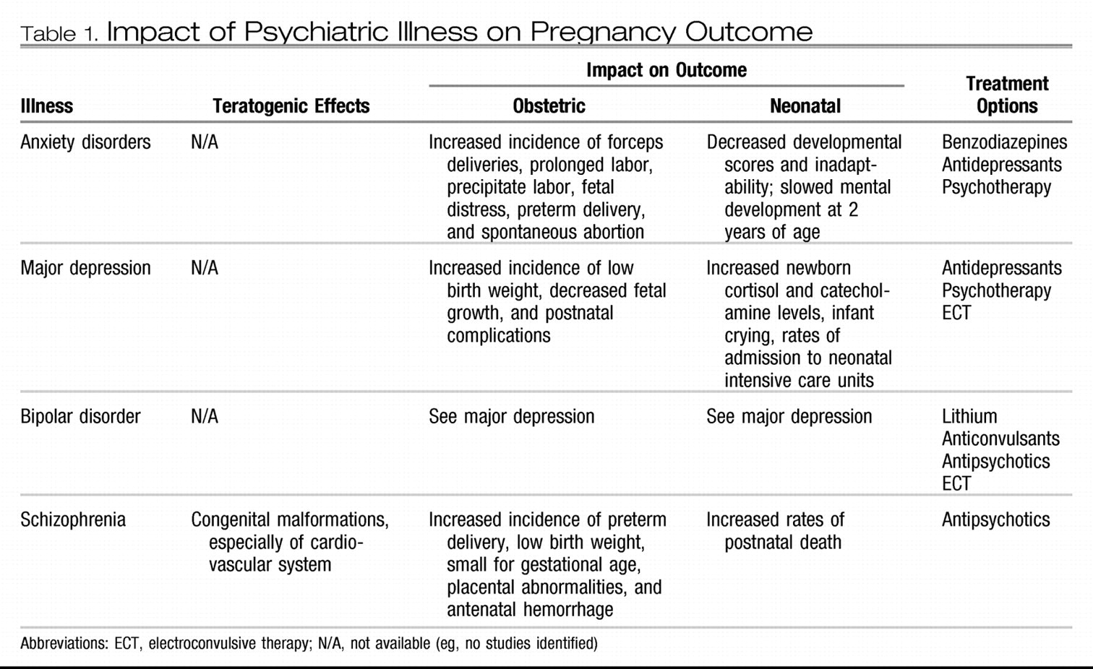

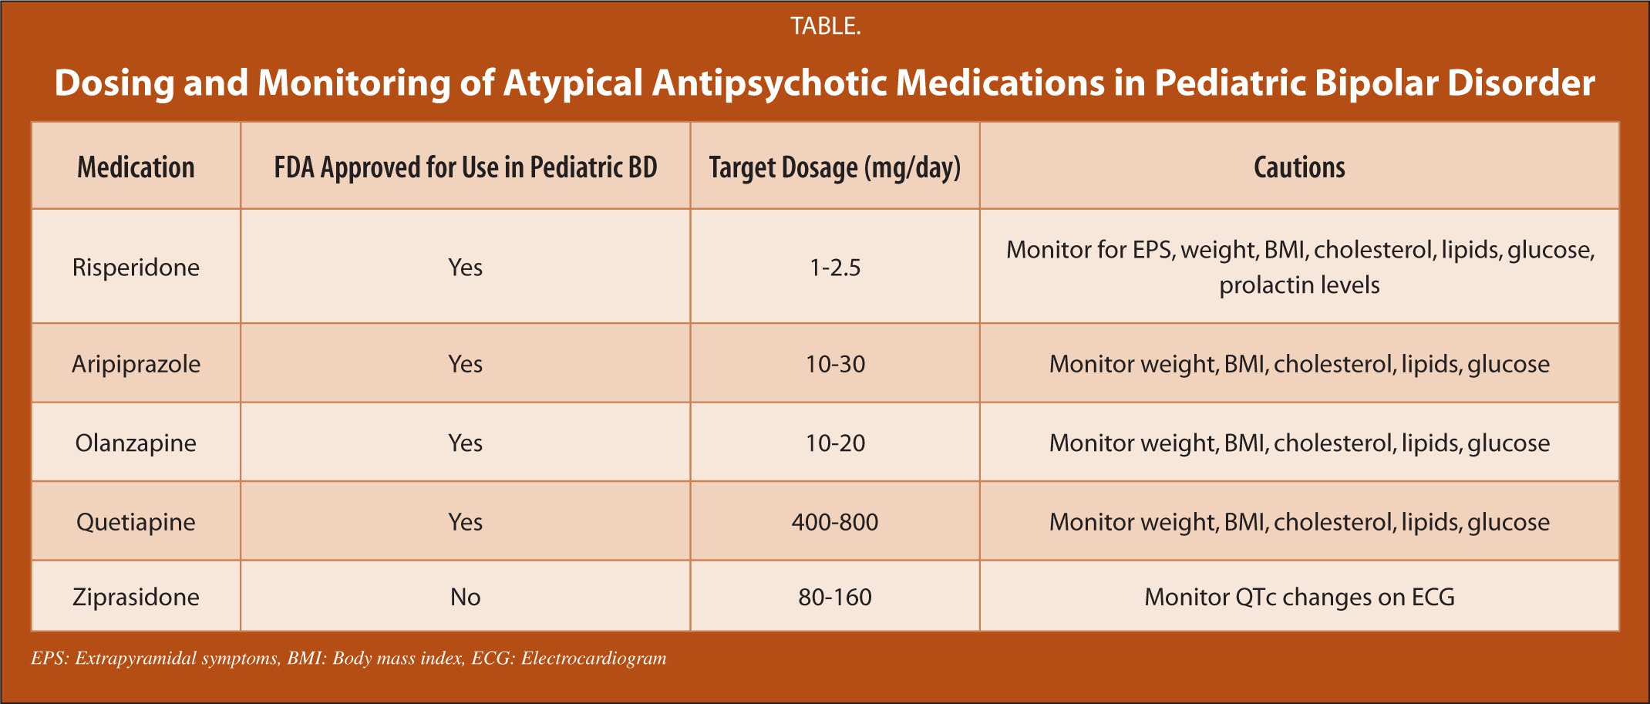

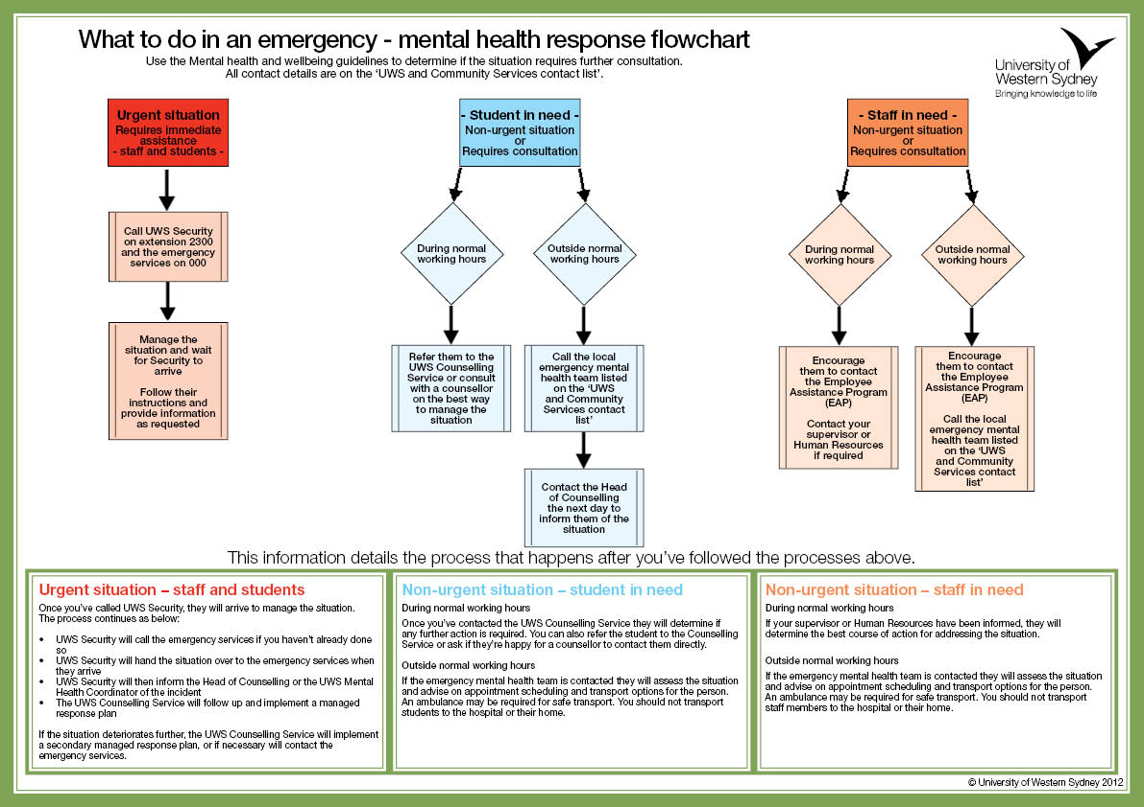

References

Breedlove, S. M., & Watson, N. V. (2020). Behavioral neuroscience. Sinauer Associates.
CBS Publishers & Distributors, Pvt. Ltd. (2017). Diagnostic and statistical manual of mental disorders: Dsm-5.
Get help. Typical and Atypical Antipsychotic Drugs. (n.d.). Retrieved November 27, 2021, from https://www.goodtherapy.org/drugs/anti-psychotics.html.
Prescription prices, coupons & pharmacy information. GoodRx. (n.d.). Retrieved December 6, 2021, from https://www.goodrx.com/.
Google. (n.d.). Google Images. Retrieved December 3, 2021, from http://images.google.com/.
Heldt, J. P. (2017). Memorable psychopharmacology. CreateSpace Independent Publishing Platform.
Peterson, A. L. (2019). Psych meds made simple: How & why they do what they do. Mental Health@Home Books.
Stahl, S. M. (2021). Stahl's essential psychopharmacology: Neuroscientific basis and practical applications. Cambridge University Press.
Stahl, S. M., Grady, M. M., & Muntner, N. (2021). Stahl's essential psychopharmacology: prescriber's guide. Cambridge University Press.

